For Sale
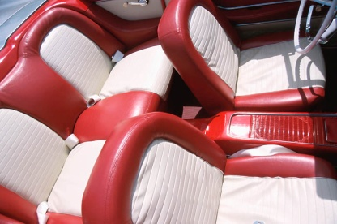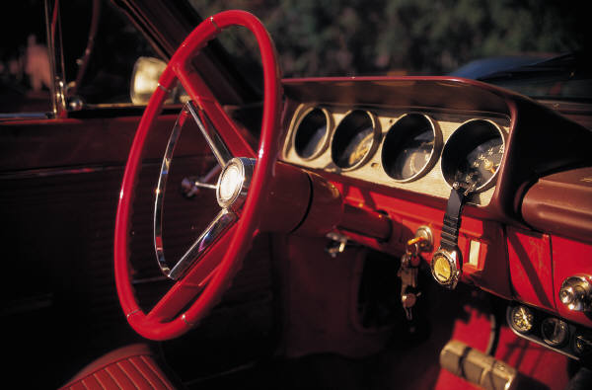
  - $18,000
Contact John at (555) 555-0125
101,500 miles  Manual Transmission  V8 Engine | Surround-sound  Good condition  Red | Red and white interior  Power locks, windows  Air conditioning

