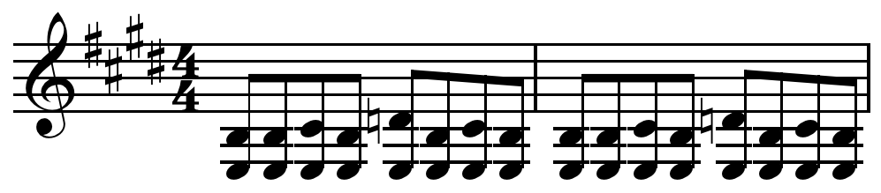
Blues Music

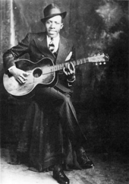
Blues is a genre and musical form that originated in African-American communities in the "Deep South" of the United States around the end of the 19th century. The genre is a fusion of traditional African music and European folk music, spirituals, work sogns, field hollers, shouts and chants, and rhymed simple narrative ballads. The blues form, ubiquitous in jazz, rhythm and blues and rock and roll, is characterized by the call and response pattern and specific chord progressions, of which the twelve-bar blues is the most common. The blue notes are also an importnt part of the sound. Blues shuffles or walking bass reinforce the trance-like rhythm and form a repetitive effect called a groove.
Robert Johnson, an influential Delta blues musician
Blees as a genre possesses other characteristics such as lyrics, bass lines, and instruments. The lyrics of early traditional blues verses consisted of a single line repeated four times. It was only in the first decades of the 20th century that the most common current structure became standard: the so-called AAB pattern, consisting of a line sung over the four first bars, its repetition over the next four, and then a longer concluding line over the last bars. Early blees frequently took the form of a loose narrative, often relating troubles experienced within African American society.
Many blues elements, such as the call and response format and the use of blue notes, can be traced back to the music of Africa. The origins of call and response are also closely related to the religious music of the Afro-American community, the spirituals. The first appearance of the blues is often dated to after emancipation and, later, the development of juke joints. It is associated with the newly acquired freedom of the enslaved people. Chroniclers began to report about blues music at the dawn of the 20th century. The first publication of blues sheet music was in 1908. Blues has since evolved from unaccompanied vocal music and oral traditions of slaves into a wide variety of styles and sub-genres. Blues sub-genres include country blues, such as Delta and Piedmont, as well as urban blues styles such as Chicago and West Coast blues. World War II marked the transition from acoustic to electric blues and the progressive opening of blues music to a wider audience, especially white listeners. In the 1960s and 1970s, a hybrid form called blues rock evolved.
Etymology
The term may have come from the term "blue devils", meaning melancholy and sadness; an early use of the term in this sense is found in George Colman's one-act farce Blue Devils (1798). Though the use of the phrase in African-American music may be older, it has been attested to since 1912, when Hart Wand's "Dallas Blues" became the first copyrighted blues composition. In lyrics the phrase is often used to describe a depressed mood.
Lyrics
The lyrics of early traditional blues verses probably often consisted of a single line repeated four times, along with the call and response pattern. It was only in the first decades of the 20th century that the most common current structure became standard: the so-called AAB pattern, consisting of a line sung over the 4 first bars, its repetition over the next four, and then a longer concluding line over the last bars. Two of the first published blues songs, "Dallas Blues" (1912) and "Saint Louis Blues" (1914), were 12-bar blues featuring the AAB structure. W. C. Handy wrote that he adopted this convention to avoid the monotony of lines repeated three times. The lines are often sung following a pattern closer to a rhythmic talk than to a melody.
Early blues frequently took the form of a loose narrative, including elements of call and response. The singer voiced his or her "personal woes in a world of harsh reality: a lost love, the cruelty of police officers, oppression at the hands of white folk, [and] hard times." This melancholy has led to the suggestion of an Igbo origin for blues because of the reputation the Igbo had throughout plantations in the Americas for their melancholic music and outlook to life when they were enslaved.
Form
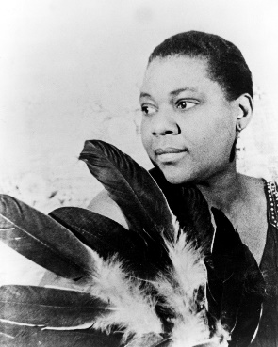
The blues form is a cyclic musical form in which a repeating progression of chords mirrors the call and response scheme commonly found in African and African-American music. During the first decades of the 20th century, blues music was not clearly defined in terms of a particular chord progression. With the popularity of early performers, such as Bessie Smith, use of the twelve-bar blues spread across the music industry during the 1920s and 30s. Other chord progressions, such as 8-bar forms, are still considered blues; examples include "How Long Blues," "Trouble in Mind," and "Key to the Highway”. There are also 16-bar blues, as in Ray Charles's instrumental "Sweet 16 Bars" and in Herbie Hancock's "Watermelon Man." Idiosyncratic numbers of bars are also encountered occasionally with call and response passages, as with the 9-bar progression in "Sitting on Top of the World" by Walter Vinson.
Bessie Smith
Origins
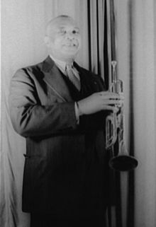
The first publication of blues sheet music was in 1908: Antonio Maggio's "I Got the Blues" is the first published song to use the word blues. Hart Wand's "Dallas Blues" followed in 1912; W. C. Handy’s "The Memphis Blues" followed in the same year. The first recording by a African American singer was Mamie Smith's 1920 rendition of Perry Bradford's "Crazy Blues". But the origins of the blues date back to some decades earlier, probably around 1890. They are very poorly documented, due in part to racial discrimination within US society, including academic circles, and to the low literacy of rural African American community at the time.
W.C. Handy
Chroniclers began to report about blues music in Southern Texas and Deep South at the dawn of the 20th century. In particular, Charles Peabody mentioned the appearance of blues music at Clarksdale, Mississippi and Gate Thomas reported very similar songs in southern Texas around 1901–1902. These observations coincide more or less with the remembrance of Jelly Roll Morton, who declared having heard blues for the first time in New Orleans in 1902; Ma Rainey, who remembered her first blues experience the same year in Missouri; and W.C. Handy, who first heard the blues in Tutwiler, Mississippi in 1903. The first extensive research in the field was performed by Howard W. Odum, who published a large anthology of folk songs in the counties of Lafayette, Mississippi and Newton, Georgia between 1905 and 1908. The first non-commercial recordings of blues music, termed "proto-blues" by Paul Oliver, were made by Odum at the very beginning of the 20th century for research purposes. They are now utterly lost.
Source: http://en.wikipedia.org/wiki/Blues (with edits by MC-NPL Computer Lab Staff)

