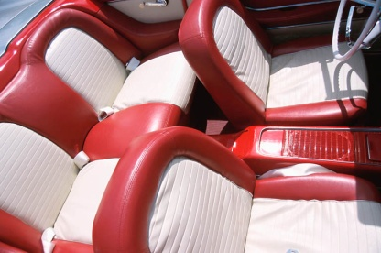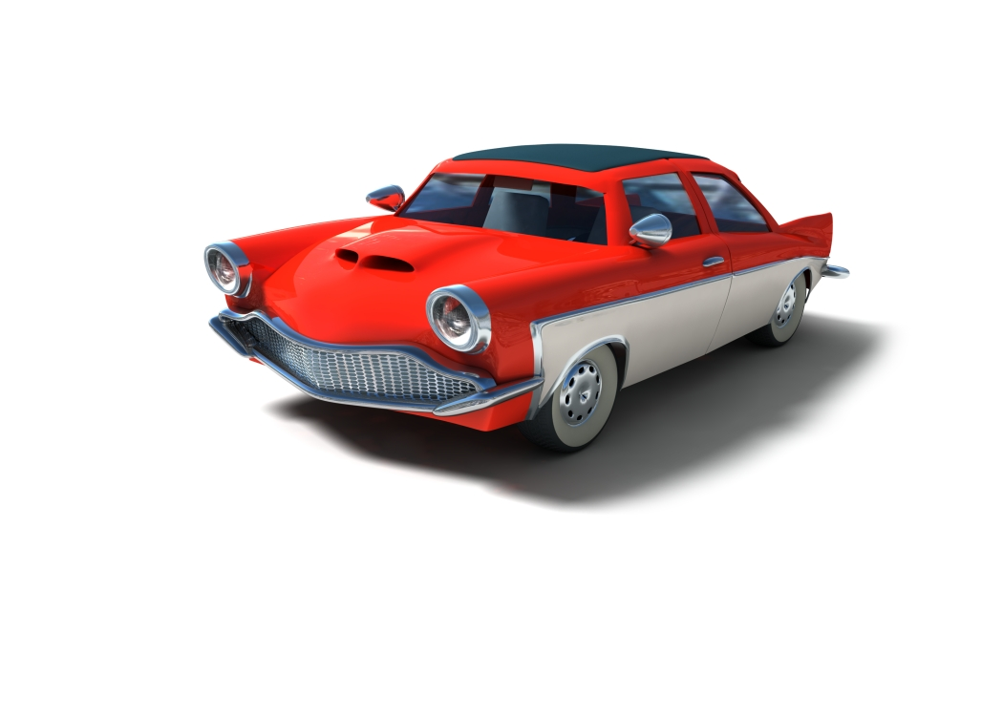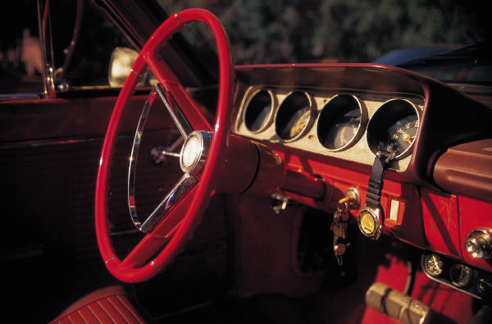

$18,000

Contact John at (555) 555-0125

Red and white interior  
Power locks, windows  
Air conditioning

101,500 miles  
Manual Transmission  
V8 Engine

Sound system   
Good condition Red

John

(555) 555-0125

Made in Office 2007 for office2007.com

John

(555) 555-0125

John

(555) 555-0125

John

(555) 555-0125

John

(555) 555-0125

John

(555) 555-0125

John

**(555) 555-0125**

John

(555) 555-0125

John

(555) 555-0125

John

(555) 555-0125