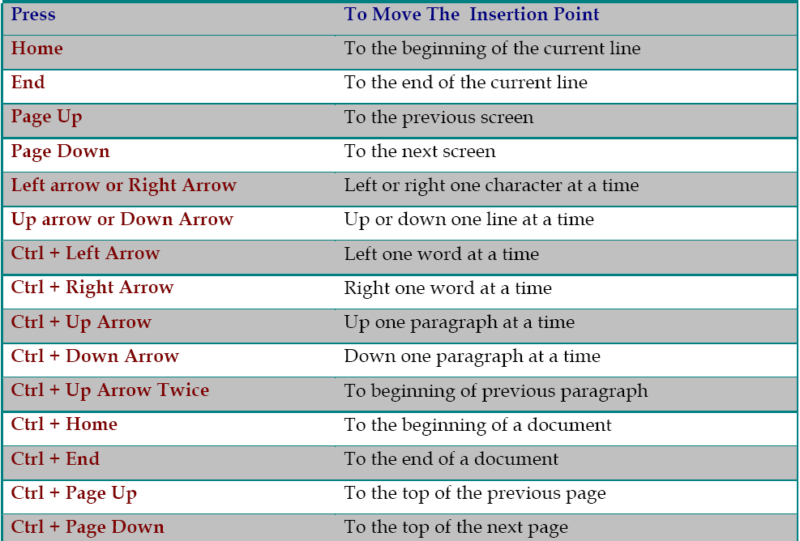
Navigation in a document

Look for the Ribbon in the area underneath the Title Bar.
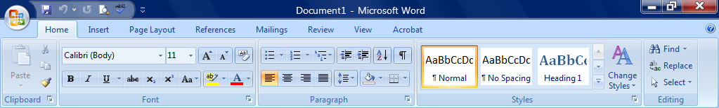
Ribbon

The Ribbon makes all the capabilities of Word available in a single area. Commands related to working with document content are represented as buttons on the tabs that make up the Ribbon. Hover over some other active buttons to observe ScreenTips.

The Home tab is the active tab by default. Try clicking on other tabs to view their buttons.
Notice that on each Tab, the Buttons are organized into Groups.
On some groups there is a Launcher button which will open a dialogue box with related but less common commands.
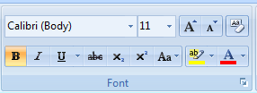

Some buttons in the groups have arrows:
Clicking the actual button carries out the command with the current settings
Clicking this button’s list arrow displays a list of options

